Exercise 1: Entailment Checking in a Smart-Home Alarm (Propositional Logic)

Name : - G Naresh Reddy
Reg no : - 192372152

Aim
To verify logical entailment (KB |= query) by model checking over all truth assignments.
Algorithm
- List all propositional symbols (M, A, D, S).
- Generate all 2^n truth assignments with itertools.product.
- Evaluate the KB (conjunction of all rules and facts) and the query in each model.
- If there is any model where KB is True and the query is False, entailment fails.
- Otherwise the KB entails the query.
Program
import itertools
symbols = ['M', 'A', 'D', 'S'] # Motion, Armed, Door open, Siren

def kb(v):
r1 = (not (v['M'] and v['A'])) or v['S'] # (M ^ A) -> S
r2 = (not v['D']) or v['M'] # D -> M
return r1 and r2 and v['A'] and v['D'] # A, D are facts

def entails(query):
print(f"{'M':<3}{'A':<3}{'D':<3}{'S':<3}{'KB':<4}{'Query':<6}")
ok = True
for vals in itertools.product([True, False], repeat=len(symbols)):
v = dict(zip(symbols, vals))
k, q = kb(v), query(v)
print(f"{int(v['M']):<3}{int(v['A']):<3}{int(v['D']):<3}{int(v['S']):<3}{int(k):<4}{int(q):<6}")
if k and not q:
ok = False
return ok

print("Query: S (siren rings)")
print("KB entails S ?", entails(lambda v: v['S']))
print("\nQuery: not S")
print("KB entails not S ?", entails(lambda v: not v['S']))
Output:
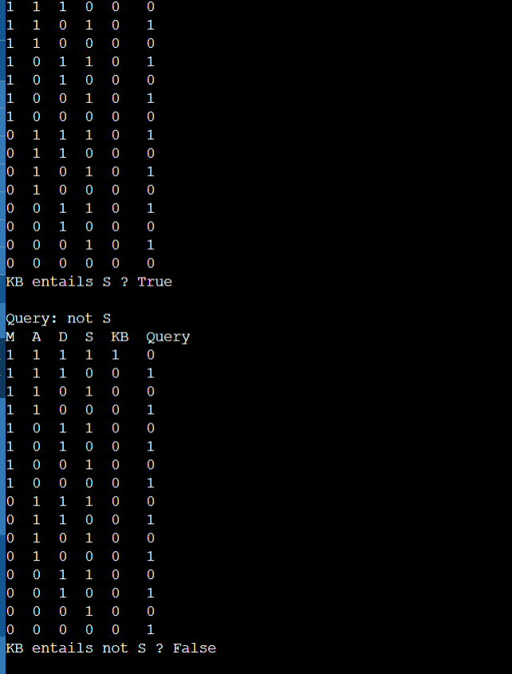
Result: The only model satisfying the KB has S = True, so KB |= S. The siren will ring. KB does not entail NOT S.

Exercise 2: Resolution Refutation for a Login System (Propositional Logic)
Aim
To prove a propositional query by converting the KB to clause form and deriving the empty clause.
Algorithm
- Convert the KB to CNF: (~P v Q), (~Q v R), (P).
- Negate the query and add it: (~R).
- Pick every pair of clauses, and if one has literal L and the other ~L, produce the resolvent (union without L and ~L).
- Add new resolvents to the clause set.
- If the empty clause appears, the query is proved. If no new clauses appear, it is not provable.
Program
from itertools import combinations

def neg(l): return l[1:] if l.startswith('~') else '~' + l

def resolve(c1, c2):
out = []
for l in c1:
if neg(l) in c2:
out.append(frozenset((c1 - {l}) | (c2 - {neg(l)})))
return out

def fmt(c): return '{' + ', '.join(sorted(c)) + '}' if c else '{} (empty)'

clauses = [frozenset({'~P', 'Q'}), frozenset({'~Q', 'R'}), frozenset({'P'}),
frozenset({'~R'})] # last clause = negated query
print("Initial clauses:")
for i, c in enumerate(clauses, 1): print(f" C{i}: {fmt(c)}")

known = set(clauses); step = 0; proved = False
while not proved:
new = set()
for c1, c2 in combinations(list(known), 2):
for r in resolve(c1, c2):
if r not in known and r not in new:
step += 1
print(f"Step {step}: resolve {fmt(c1)} & {fmt(c2)} -> {fmt(r)}")
new.add(r)
if not r: proved = True; break
if proved: break
if proved: break
if not new: break
known |= new
print("\nQuery R proved by refutation:", proved)

Output:
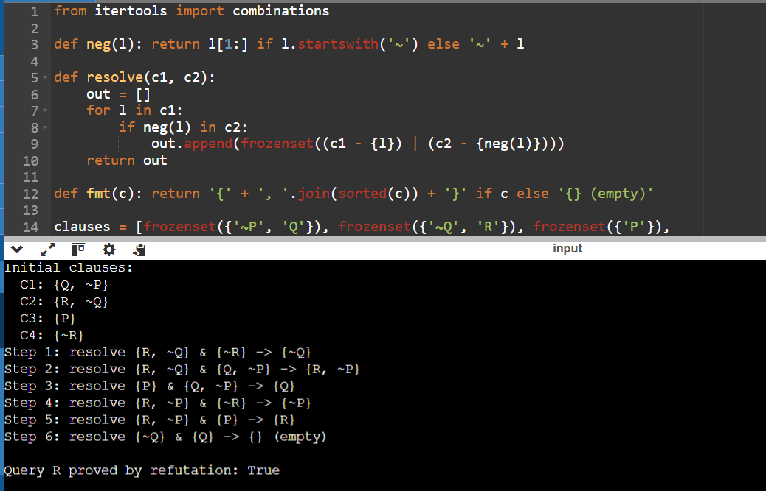
Result: The empty clause was derived, so the KB together with ~R is unsatisfiable. Hence R (dashboard accessible) logically follows from the rules.

Exercise 3: Unification for Student-Course Queries (Predicate Logic)
Aim
To implement the unification algorithm that finds a substitution making two first-order terms identical.
Algorithm
- If x equals y, return the current substitution.
- If x is a variable, call UnifyVar(x, y). If y is a variable, call UnifyVar(y, x).
- If both are tuples of equal length, unify them element by element, passing the substitution along.
- Otherwise return failure (None).
- UnifyVar(v, t): if v is already bound, unify its binding with t. Otherwise add v -> t.
Program
def is_var(x): return isinstance(x, str) and x[0].isupper()

def unify(x, y, s):
if s is None: return None
if x == y: return s
if is_var(x): return unify_var(x, y, s)
if is_var(y): return unify_var(y, x, s)
if isinstance(x, tuple) and isinstance(y, tuple) and len(x) == len(y):
for a, b in zip(x, y):
s = unify(a, b, s)
return s
return None

def unify_var(v, t, s):
if v in s: return unify(s[v], t, s)
if is_var(t) and t in s: return unify(v, s[t], s)
return {**s, v: t}

tests = [
(('enrolled', 'S', 'ds101'), ('enrolled', 'alice', 'ds101')),
(('teaches', 'P', 'C'), ('teaches', 'rao', 'ke201')),
(('teaches', 'rao', 'C'), ('teaches', 'kumar', 'ke201')),
(('advisor', 'X', ('dept', 'Y')), ('advisor', 'meena', ('dept', 'cse'))),
(('f', 'X', 'Y'), ('f', 'Y', 'a')),
]
for a, b in tests:
print(a, '<->', b, '=>', unify(a, b, {}))

Output:
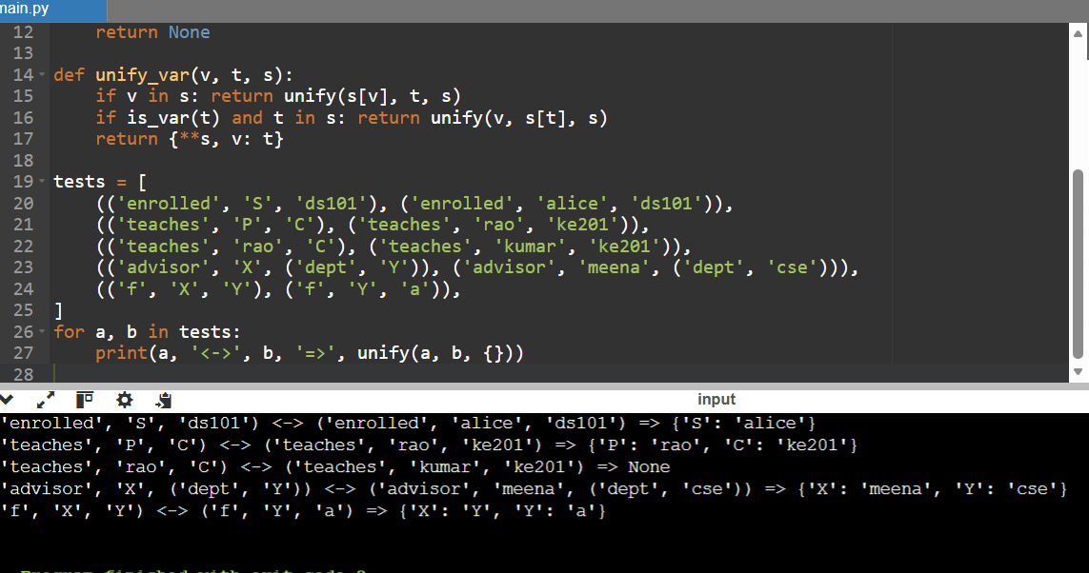
Result: Unification correctly binds variables to constants (including nested terms), and fails (None) for the clash rao vs kumar. The last case shows chained bindings X -> Y -> a. This implementation omits the occurs-check for simplicity.

Exercise 4: Evaluating Quantified Statements over a Class (Predicate Logic)
Aim
To evaluate universally and existentially quantified formulas over a finite domain (model) and verify that NOT EXISTS NOT-P is equivalent to FORALL P.
Algorithm
- Define the domain of discourse (the students) and the predicates (as dictionaries and sets).
- Translate FORALL into all(...) and EXISTS into any(...). Translate implication A -> B as (not A) or B.
- Evaluate each statement and print the truth value.
- Compare S1 and S4 to check De Morgan's law for quantifiers.
Program
students = ['Arun', 'Bala', 'Chitra', 'Divya']
enrolled = {'Arun': {'KE', 'DS'}, 'Bala': {'KE'}, 'Chitra': {'DS'}, 'Divya': {'KE', 'DS'}}
attends = {'Arun', 'Bala', 'Divya'}
ds_marks = {'Arun': 92, 'Chitra': 78, 'Divya': 85}

S1 = all((('KE' not in enrolled[x]) or (x in attends)) for x in students)
S2 = any(('DS' in enrolled[x] and ds_marks.get(x, 0) >= 90) for x in students)
S3 = all(any(True for c in enrolled[x]) for x in students)
S4 = not any(('KE' in enrolled[x] and x not in attends) for x in students)
S5 = all(ds_marks.get(x, 0) >= 80 for x in students if 'DS' in enrolled[x])

print("S1: forall x (Enrolled(x,KE) -> Attends(x)) :", S1)
print("S2: exists x (Enrolled(x,DS) ^ Marks(x,DS)>=90) :", S2)
print("S3: forall x exists c Enrolled(x,c) :", S3)
print("S4: not exists x (Enrolled(x,KE) ^ not Attends(x)) :", S4)
print("S5: forall x (Enrolled(x,DS) -> Marks(x,DS)>=80) :", S5)
print("Quantifier duality holds (S1 == S4):", S1 == S4)
Output:
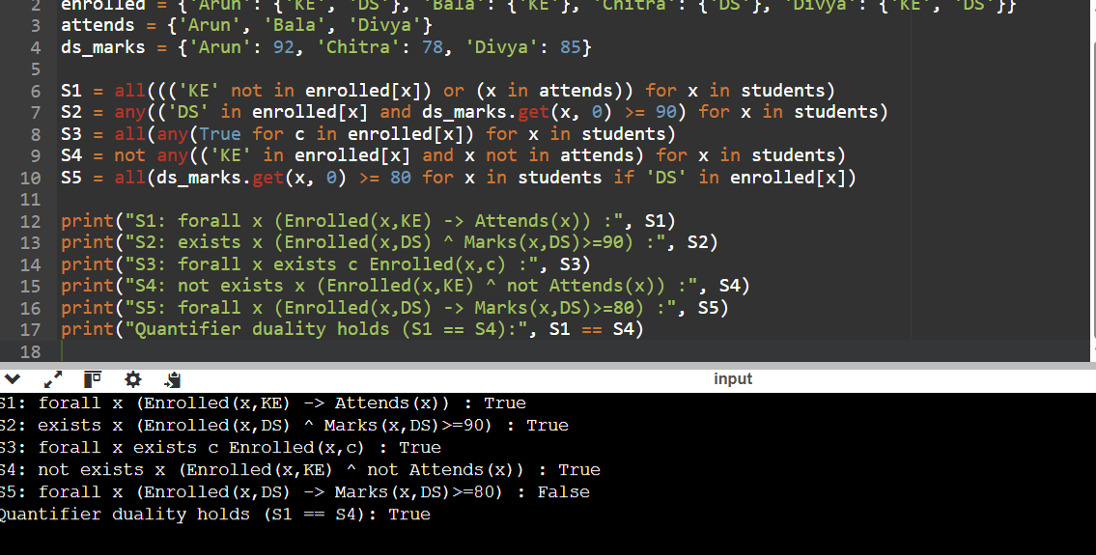
Result: S1 to S4 are true; S5 is false because Chitra (DS, 78) has marks below 80. S1 and S4 always agree, confirming the duality law.

Exercise 5: Modus Ponens and Modus Tollens in Network Fault Diagnosis (Inference Mechanisms)
Aim
To implement two basic inference rules: Modus Ponens (A, A->B therefore B) and Modus Tollens (NOT B, A->B therefore NOT A).
Algorithm
- Store the rules as (antecedent, consequent) pairs and the known facts in a dictionary.
- Repeat until nothing changes:
  - For each rule A->B, if A is True and B is unknown, set B = True (Modus Ponens).
  - If B is False and A is unknown, set A = False (Modus Tollens).
- Print every inference step and the final state.
Program
rules = [('Power', 'RouterOn'), ('RouterOn', 'WifiOn'), ('WifiOn', 'InternetOK')]

def infer(known):
changed = True
while changed:
changed = False
for a, c in rules:
if known.get(a) is True and c not in known:
known[c] = True; changed = True
print(f"Modus Ponens : {a} true and ({a}->{c}) => {c} = True")
if known.get(c) is False and a not in known:
known[a] = False; changed = True
print(f"Modus Tollens: {c} false and ({a}->{c}) => {a} = False")
return known

print("Case A: Power = True")
print("Result:", infer({'Power': True}))
print("\nCase B: InternetOK = False")
print("Result:", infer({'InternetOK': False}))
Output:
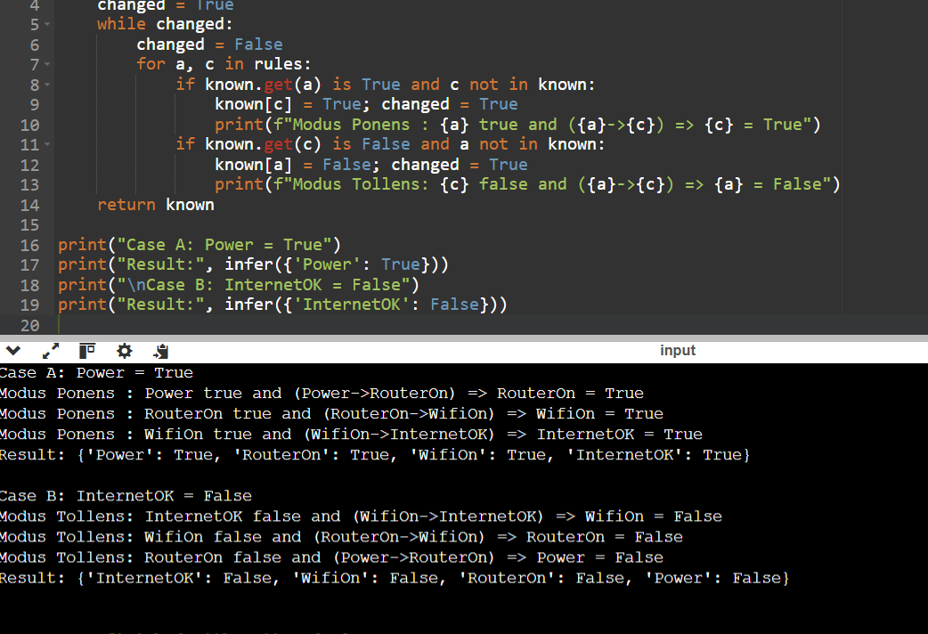
Result: Modus Ponens propagates truth forward along the chain (power on implies internet OK). Modus Tollens propagates falsity backward (no internet implies Wi-Fi, router and power are all not working under this rule set).

Exercise 6: Loan Eligibility Using Forward Chaining (Forward and Backward Chaining)
Aim
To implement forward chaining (data-driven inference) in a production-rule system.
Algorithm
- Initialise working memory with the known facts.
- Scan the rules. If all premises of a rule are in the facts and its conclusion is not, fire the rule and add the conclusion.
- Repeat the scan until no rule can fire (fixed point).
- Check whether the goal is in the final fact set.
Program
rules = [
({'employed', 'salary_above_30k'}, 'stable_income'),
({'stable_income', 'credit_score_good'}, 'low_risk'),
({'low_risk', 'has_collateral'}, 'loan_approved'),
({'loan_approved'}, 'send_offer_letter'),
]
facts = {'employed', 'salary_above_30k', 'credit_score_good', 'has_collateral'}
print("Initial facts:", sorted(facts))

fired = True; n = 0
while fired:
fired = False
for prem, concl in rules:
if prem <= facts and concl not in facts:
facts.add(concl); n += 1; fired = True
print(f"Cycle {n}: {sorted(prem)} => {concl}")
print("Final facts:", sorted(facts))
print("Loan approved?", 'loan_approved' in facts)
Output:
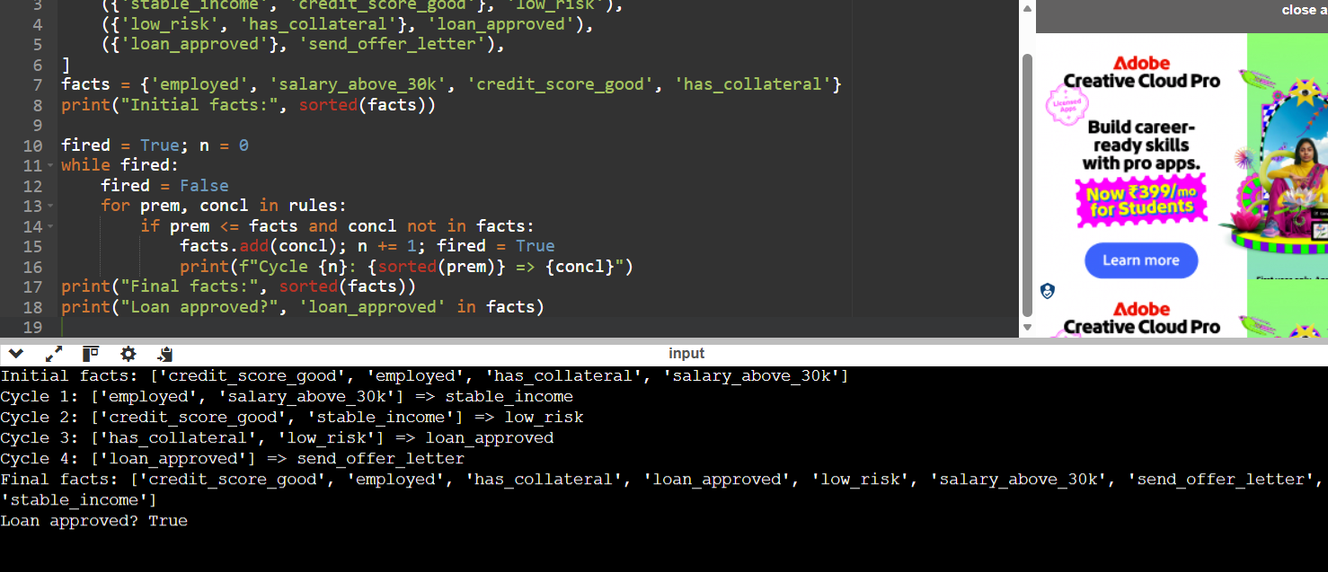
Result: Four rules fired in sequence and the system concluded that the loan is approved and an offer letter should be sent. Forward chaining derives all consequences of the data, whether or not they were asked for.

Exercise 7: Laptop Fault Diagnosis Using Backward Chaining (Forward and Backward Chaining)
Aim
To implement backward chaining (goal-driven inference) that proves a goal by recursively proving its sub-goals.
Algorithm
- To prove goal G: if G is a known fact, return True.
- If G is not the conclusion of any rule, return False.
- Otherwise, for each rule that concludes G, try to prove all its premises recursively.
- If all premises of some rule hold, G is True. Otherwise G is False.
- Print the sub-goal trace using indentation by depth.
Program
rules = {
'battery_fault': [['screen_black', 'power_led_off', 'charger_connected']],
'display_fault': [['screen_black', 'power_led_on', 'fan_running']],
'ram_fault' : [['power_led_on', 'beeps']],
}
facts = {'screen_black', 'power_led_off', 'charger_connected'}

def bc(goal, depth=0):
pad = ' ' * depth
if goal in facts:
print(f"{pad}{goal}: found in facts -> True"); return True
if goal not in rules:
print(f"{pad}{goal}: no fact, no rule -> False"); return False
for prem in rules[goal]:
print(f"{pad}Goal {goal}: need {prem}")
if all(bc(p, depth + 1) for p in prem):
print(f"{pad}{goal} -> True"); return True
print(f"{pad}{goal} -> False"); return False

for g in ['battery_fault', 'display_fault', 'ram_fault']:
print(f"\n== Proving {g} ==")
print("Result:", bc(g))

Output:
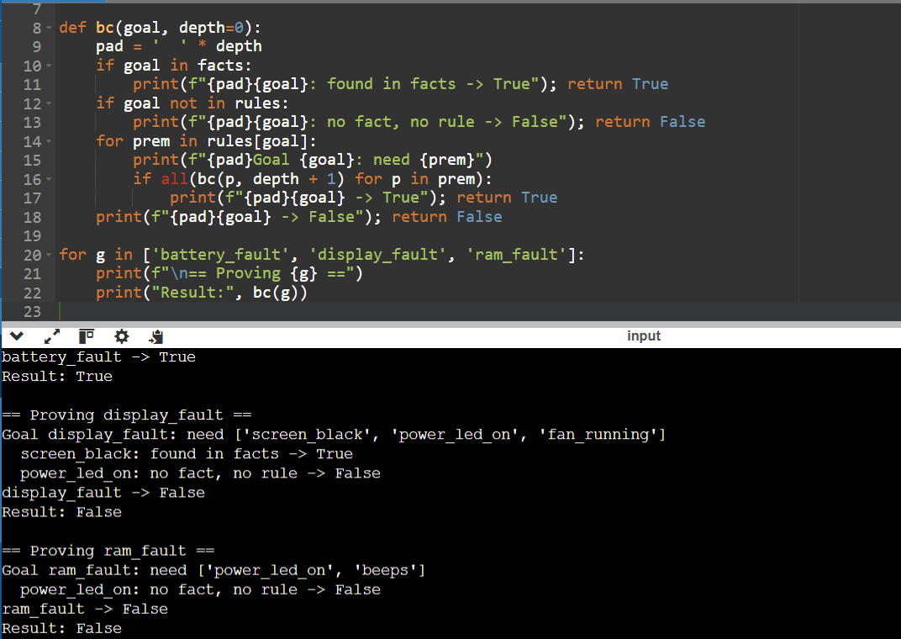
Result: Only battery_fault is provable from the observations. Backward chaining examined only the sub-goals relevant to each hypothesis and stopped early on failure, which makes it efficient for diagnosis, unlike forward chaining (Exercise 6), which derives everything.

Exercise 8: Medical Screening with Bayes' Theorem (Probabilistic Reasoning)
Aim
To apply the law of total probability and Bayes' theorem for sequential belief updating.
Algorithm
- Set prior P(D), sensitivity and specificity.
- Evidence: P(E) = P(E|D) P(D) + P(E|~D) P(~D).
- Posterior: P(D|E) = P(E|D) P(D) / P(E).
- For a second independent test, use the first posterior as the new prior.
- For a negative result, use P(-|D) = 1 - sensitivity and P(-|~D) = specificity.
Program
prior, sens, spec = 0.02, 0.95, 0.90

def update(p, positive=True):
like_d = sens if positive else 1 - sens
like_n = (1 - spec) if positive else spec
evidence = like_d * p + like_n * (1 - p)
return like_d * p / evidence, evidence

p1, e1 = update(prior)
p2, e2 = update(p1)
pn, _ = update(prior, positive=False)

print(f"Prior P(Disease) = {prior:.4f}")
print(f"P(Test+) (total probability) = {e1:.4f}")
print(f"P(Disease | Test1 +) = {p1:.4f}")
print(f"P(Disease | Test1 +, Test2 +) = {p2:.4f}")
print(f"P(Disease | Test1 -) = {pn:.4f}")

Output:
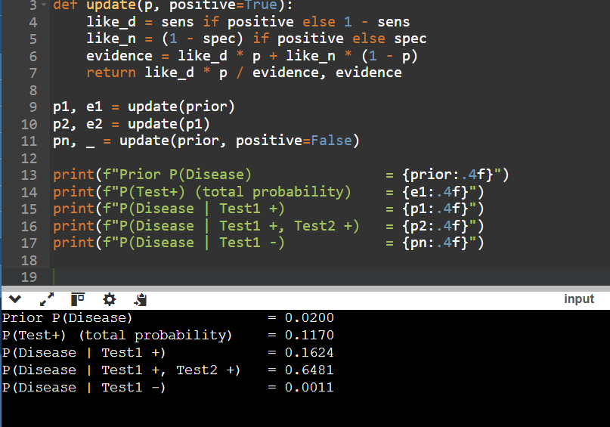
Result: Even with a fairly accurate test, a single positive result gives only about 16% probability of disease because the disease is rare (base-rate effect). A second independent positive raises it to about 65%. A negative result lowers it to about 0.1%.

Exercise 9: Burglar Alarm Inference Using a Bayesian Network (Bayesian Networks)
Aim
To perform exact inference in a Bayesian network by enumerating the joint distribution.
Algorithm
- Define the CPTs.
- The joint probability is P(B,E,A,J,M) = P(B) P(E) P(A|B,E) P(J|A) P(M|A).
- For a query variable X with evidence e, sum the joint over all worlds consistent with X = x and e, for each value x.
- Normalise the two sums so they add to 1.
Program
import itertools

P_B, P_E = 0.001, 0.002
P_A = {(True, True): 0.95, (True, False): 0.94, (False, True): 0.29, (False, False): 0.001}
P_J = {True: 0.90, False: 0.05}
P_M = {True: 0.70, False: 0.01}

def joint(b, e, a, j, m):
p = (P_B if b else 1 - P_B) * (P_E if e else 1 - P_E)
p *= P_A[(b, e)] if a else 1 - P_A[(b, e)]
p *= P_J[a] if j else 1 - P_J[a]
p *= P_M[a] if m else 1 - P_M[a]
return p

def query(var, evidence):
names = ['B', 'E', 'A', 'J', 'M']
dist = {}
for val in (True, False):
total = 0
for combo in itertools.product([True, False], repeat=5):
w = dict(zip(names, combo))
if w[var] != val: continue
if any(w[k] != v for k, v in evidence.items()): continue
total += joint(*combo)
dist[val] = total
z = sum(dist.values())
return {k: v / z for k, v in dist.items()}

for var, ev in [('B', {'J': True, 'M': True}), ('B', {'J': True}),
('E', {'J': True, 'M': True}), ('A', {'J': True, 'M': True})]:
r = query(var, ev)
print(f"P({var}=T | {ev}) = {r[True]:.4f} P({var}=F | ...) = {r[False]:.4f}")
Output:
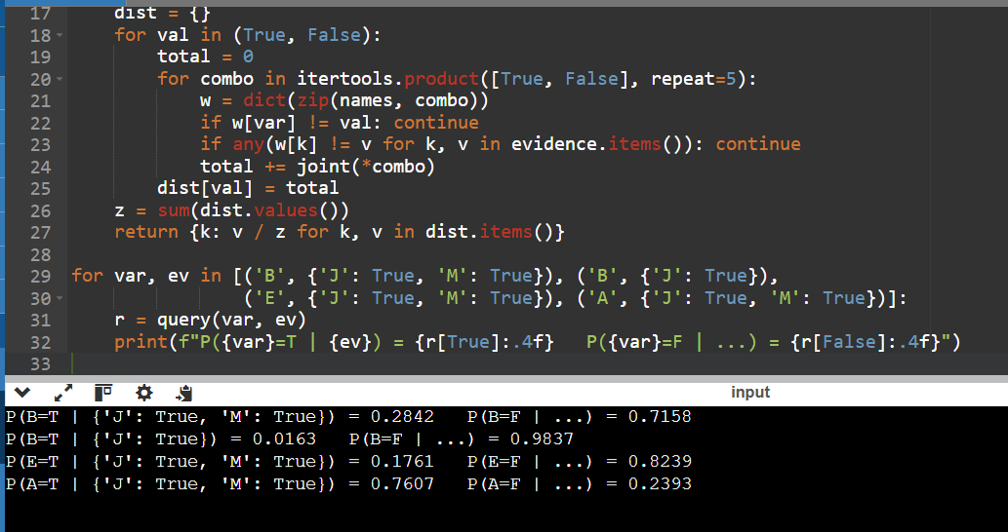
Result: With both neighbours calling, the probability of a burglary rises from the prior 0.1% to about 28.4%. With only John calling it is about 1.6%. The alarm itself is about 76% likely to have gone off. The results show how evidence propagates through the network even though no single call is conclusive.

Exercise 10: Fan Speed Controller Using a Mamdani Fuzzy System (Fuzzy Logic Systems)
Aim
To design a fuzzy inference system using fuzzification, rule evaluation, aggregation and centroid defuzzification.
Algorithm
- Fuzzify: compute membership degrees of temperature and humidity using triangular functions.
- Rule evaluation: the firing strength of a rule is min(temperature degree, humidity degree) (AND = min).
- Aggregation: for each output set take the max of the strengths of rules pointing to it.
- Clip each output set at its strength and combine with max.
- Defuzzify: centroid = sum(x * mu(x)) / sum(mu(x)) for x = 0..100.
Program
def tri(x, a, b, c):
if x <= a or x >= c: return 0.0
return (x - a) / (b - a) if x <= b else (c - x) / (c - b)

def temp_sets(t): return {'cold': tri(t,-1,0,20), 'warm': tri(t,15,25,35), 'hot': tri(t,30,40,41)}
def hum_sets(h): return {'dry': tri(h,-1,0,50), 'humid': tri(h,40,100,101)}

speed_sets = {'low': (0,20,50), 'medium': (30,50,70), 'high': (50,80,100)}
rules = [('cold','dry','low'), ('cold','humid','low'), ('warm','dry','medium'),
('warm','humid','high'), ('hot','dry','high'), ('hot','humid','high')]

def fan_speed(t, h):
T, H = temp_sets(t), hum_sets(h)
strength = {}
for tt, hh, out in rules:
w = min(T[tt], H[hh])
strength[out] = max(strength.get(out, 0), w)
num = den = 0.0
for x in range(0, 101):
mu = max(min(strength.get(o, 0), tri(x, *p)) for o, p in speed_sets.items())
num += x * mu; den += mu
return T, H, strength, (num / den if den else 0)

for t, h in [(10, 30), (28, 60), (38, 80)]:
T, H, s, y = fan_speed(t, h)
print(f"Temp={t}C Hum={h}%")
print(" temp memberships :", {k: round(v,2) for k,v in T.items()})
print(" humid memberships:", {k: round(v,2) for k,v in H.items()})
print(" rule strengths :", {k: round(v,2) for k,v in s.items()})
print(f" Fan speed (centroid) = {y:.2f} %\n")
Output:
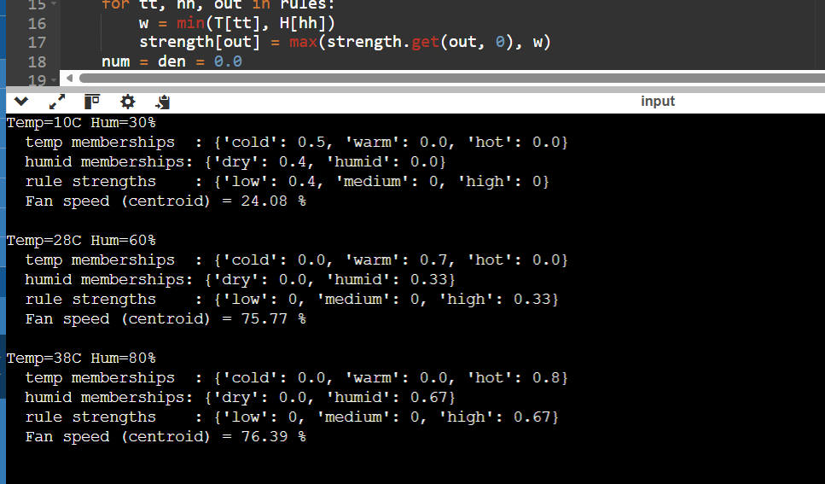
Result: The controller produces smooth, gradual outputs: about 24% for a cool, dry room, about 76% for a warm, humid room, and about 76% for a hot, humid room. Rule strengths come from partial membership rather than hard thresholds, which is the main advantage of fuzzy control.

